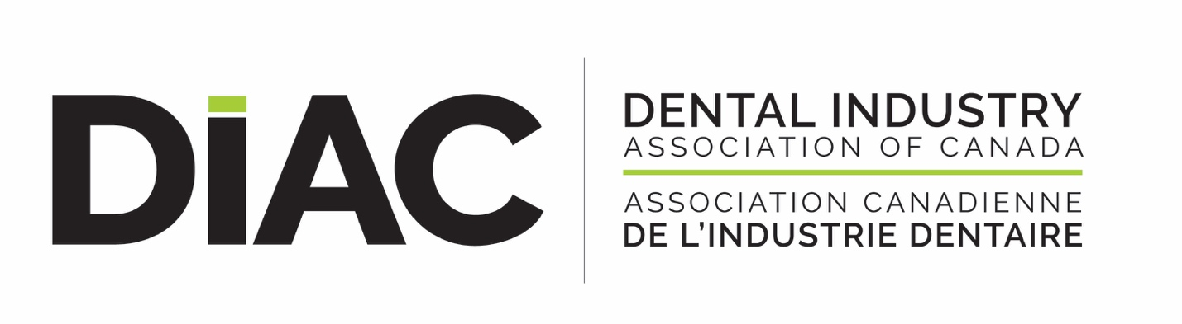
DIAC SPECIAL BULLETIN
July 16, 2020
BEWARE OF FRAUDULENT ACTIVITIES IN INDUSTRY

“BUYERS BEWARE” has now become “SELLERS BEWARE” as a string of fraudulent buying activities has once again hit our industry and impacts our relationships with the dental office community.

The following scenarios have happened in BC and Ontario and maybe happening in other provinces:

“Scenario A”
A person posing as a Dentist/Dental Assistant etc. from a legitimate dental office places an order with a distributor who then processes the order and has it shipped to the legitimate dental office address. The fraudsters then pose as representatives from the distributor, contacts the legitimate dental office and advises these products were shipped in error and they will be sending a courier company to pick them up to which they are then re-routed to a hotel, warehouse etc.

“Scenario B”
The fraudster poses as an employee of the distributor and asks the courier company to re-direct legitimate orders from the distributor to a new address.

Here are some great tips to help your business and our dental office partners to manage this fraudulent activity:

- Distributors, your customer service teams need to be extra vigilant in using a strict customer verification process before entering an order.

- Behaviours to watch out for:
  - Orders with a high quantity of items, unusual quantity ordered.
  - Orders outside of their typical history - items they haven’t previously ordered or different categories of items
  - Orders with high overall dollar amounts ($1,000 and above)

- The following items seem to be some favourites being ordered by fraudsters:

Filtek Z250; Morita Root ZX II Apex Locator; Protemp Plus Refill; Panavia V5 Paste Syringe A2; RelyX Unicem Transluc Aplicap; System B Cordless Fill Kit; System B Cordless Pack; RelyX Unicem 2 Automix Refill.

- Put security measures in place with your courier company with a verification process. If shipments are re-directed they must call to confirm.

These perpetrators seem to be very organized, convincing and looking for victims so be extremely vigilant in your order and delivery processes. Discuss this issue with your dental customers and engage their help in the control of fraud for the benefit of the whole dental community.

Rhonda Lawson
Executive Director
DIAC

